**MySQL Activity**

1. Create Database & Table and Fields: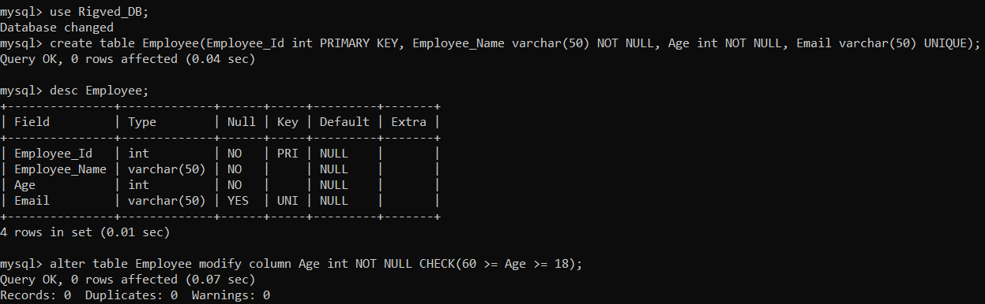
2. Alter table and modify Age with check constraint
3. Store the record and check the check constraint: 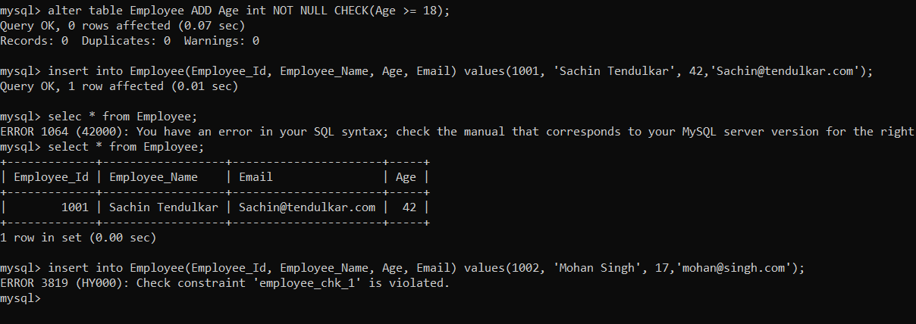
4. Store more records with same Email : 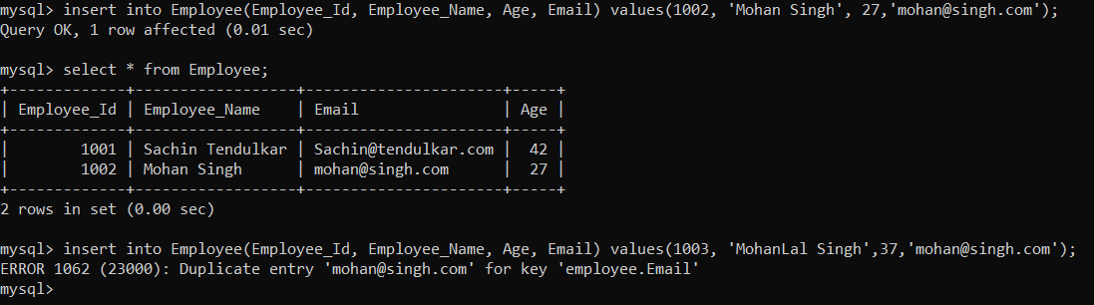
5. Alter table and add two new field PAN and AADHAAR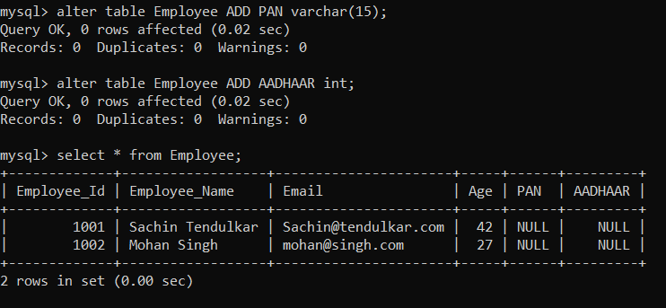
6. Alter the table and modify PAN and AADHAAR field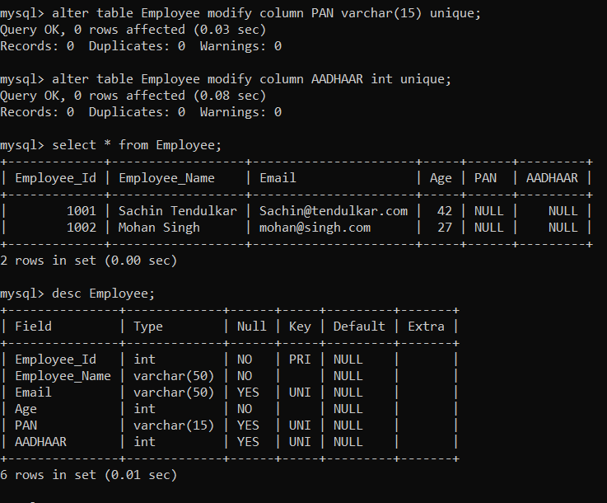
7. Check Unique constraint with passing duplicate value in same field and different record: 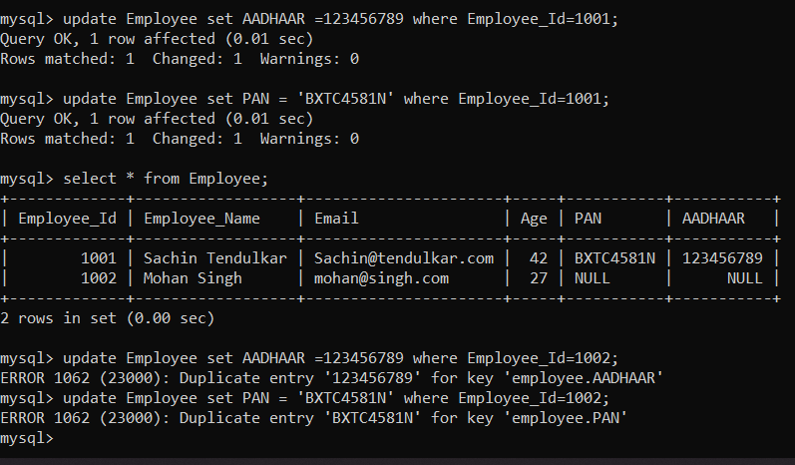
8. Alter the above employee table and remove the PAN and AADHAAR columns: 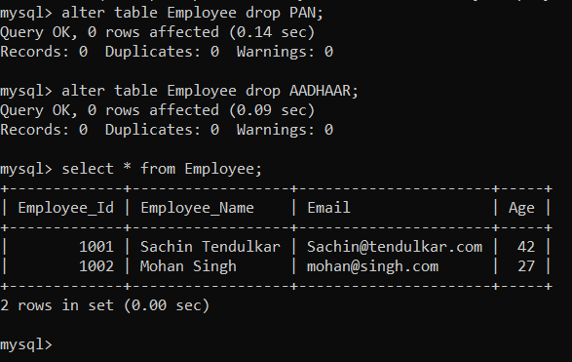
9. Using the DROP delete the employee table. 